INDEX:

|  |  |  |
| --- | --- | --- |
| 1 | Introduction of Application |  |
| 2 | Process Chart |  |
|  | 2.1. Flow Chart |  |
|  | 2.2. Master Chart |  |
| 3 | Requirements of Project |  |
|  | 3.1. Getting device data |  |
|  | 3.2. Front End |  |
|  | 3.3. Back End |  |
| 4 | Installation & Components |  |
|  | 4.1 App Component |  |
|  | 4.2 Login Component |  |
|  | 4.3 Post Login Component |  |
|  | 4.4 Navigation Component |  |
| 5 | Modules |  |
|  | 5.1 App Modules |  |
|  | 5.2 Post Login Modules |  |
| 6 | Models |  |
|  | 6.1 Machine Model |  |
|  | 6.2 User Model |  |
|  | 6.3 Role Model |  |
|  | 6.4 Index Model |  |
| 7 | Services |  |
|  | 7.1 Login Service |  |
|  | 7.2 User Service |  |
|  | 7.3 Role Service |  |
|  | 7.4 Machine Service |  |
|  | 7.5 API Service |  |
|  | 7.6 Configuration Service |  |
| 8 | Authentication |  |
|  | 8.1 Login Authentication |  |
|  | 8.2 Auth Guard - Service |  |
| 9 | Interceptor |  |
| 10 | Store |  |
|  | 10.1 Auth Store |  |
|  | 10.2 Action Types |  |
|  | 10.3 Actions |  |
|  | 10.4 Reducer |  |
|  | 10.5 Selectors |  |
| 11 | Resolvers |  |
|  | 11.1 Machine Resolvers |  |
|  | 11.2 Role Resolvers |  |
|  | 11.3 User Resolvers |  |
| 12 | Routing |  |
| 13 | Assets |  |
| 14 | Animations |  |
| 15 | Build |  |
| 16 | Unit Testing |  |

1. **INTRODUCTION :**

It is a single page application which observe the temperature and humidity of the lab with help of sensor device to monitor the readings automatically by encrypted software. Which contributes the consistent reading to monitoring the room temperature.

1. **PROCESS CHART :**
   1. **FLOW CHART :**

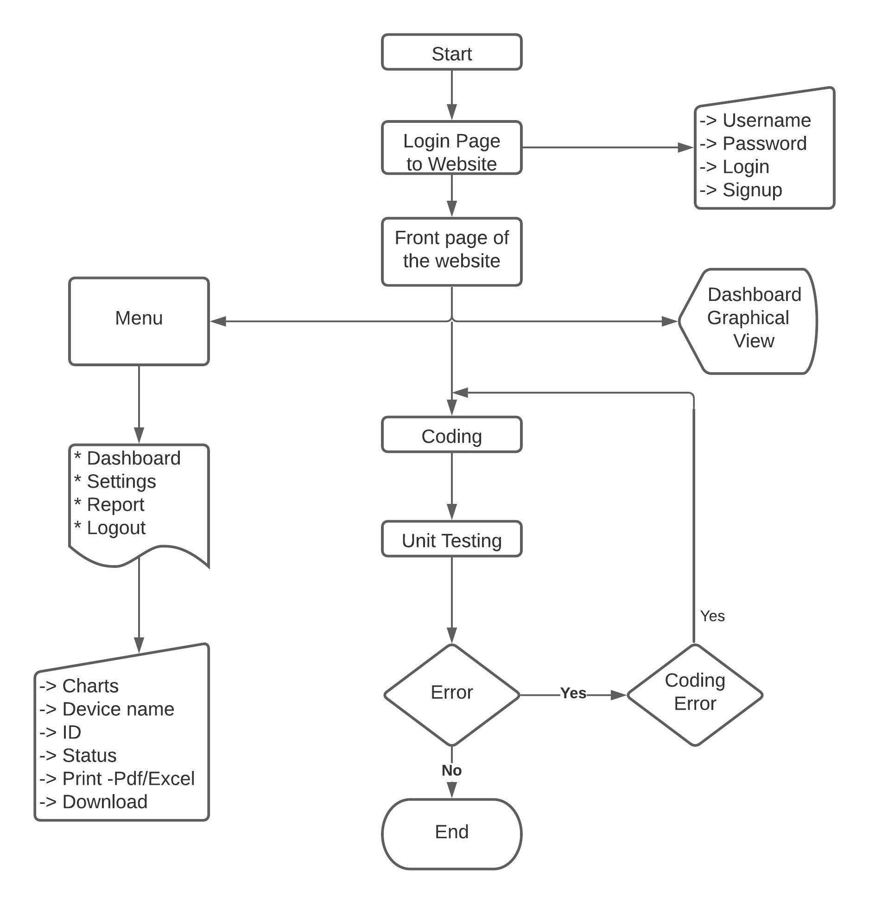

* 1. **MASTER CHART :**

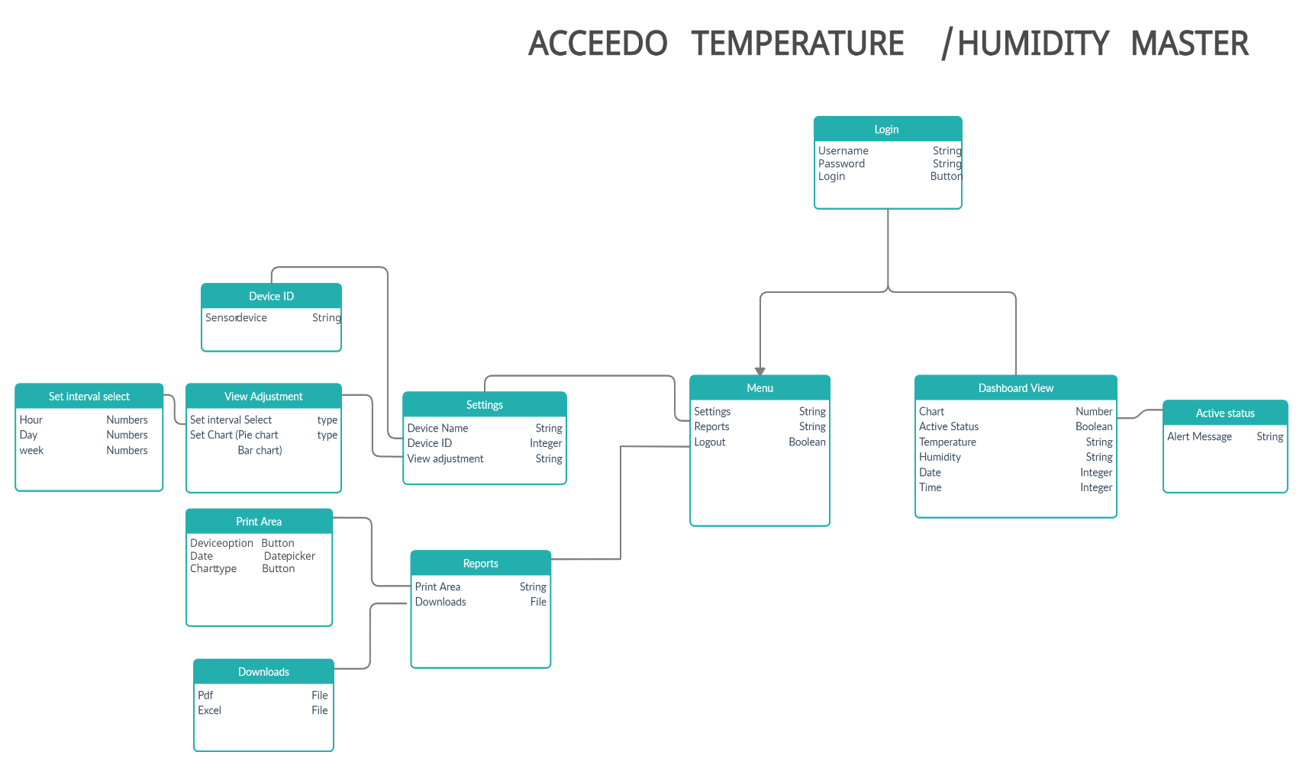

1. **REQUIREMENTS :**

**3.1. GETTING DEVICE DATA :**

MACHINE SENSOR DEVICE **:**

The sensor device which is connected to the server (URL) It sends the data every per seconds to the Server.

Data contains

* Machine Id
* Temperature
* Humidity
* Status

**3.2. FRONT END :**

**In this application we using following front end software’s**

* **Html & Scss -** Template design**.**
* **Angular -** Front End Framework.
* **Node -** Cross-platform runtime JavaScript environment leads to run angular framework
* **Angular Material -** UI design for the application.
* **Chart JS -** Graphical data representation.

**3.3. BACK END :**

**In this application we using following Back end Software’s**

* **Node JS -** Also perform Server sidejava script
* **Mongo Db -** Fully Managed Database Service.
* **Express JS –** web application server framework like Single page application, multi-page etc.

**Visual Studio Code –** Development Editor Tool

1. **INSTALLATION & COMPONENTS :**

**VISUAL STUDIO CODE :**

Visual Studio Code is a code editor redefined and optimized for building and debugging modern web and cloud applications.

**You can download Visual Studio code from URL** [**"https://code.visualstudio.com/download"**](https://code.visualstudio.com/download)

**INSTALLATION STEPS:**

1. Firstly, download the Visual Studio Code installer for Windows. Once it is downloaded, run the installer (VS Code User Setup-{version}.exe). It will only take a minute.

2. Secondly, accept the agreement and click on next.

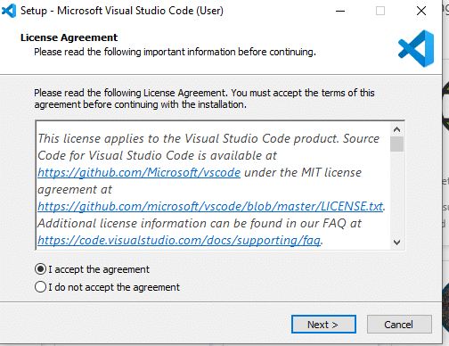

3. Thirdly, click on ***"create a desktop icon"*** so that it can be accessed from desktop and click on Next.

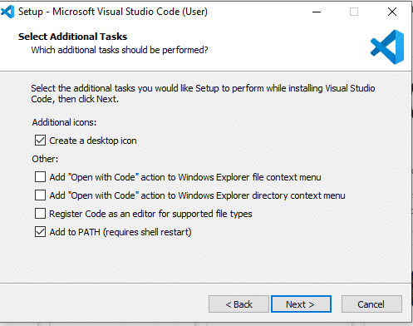

4. After that, click on the install button.

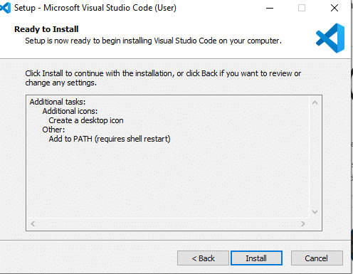

5. Finally, after installation completes, click on the finish button, and the visual studio code will get open.

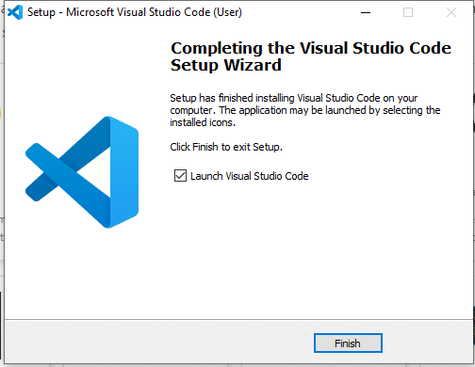

Note: By default, VS Code installs under C:\users{username}\AppData\Local

**Node JS Installation:**

1. Download the Windows installer from [Nodejs.org](http://nodejs.org/download/).

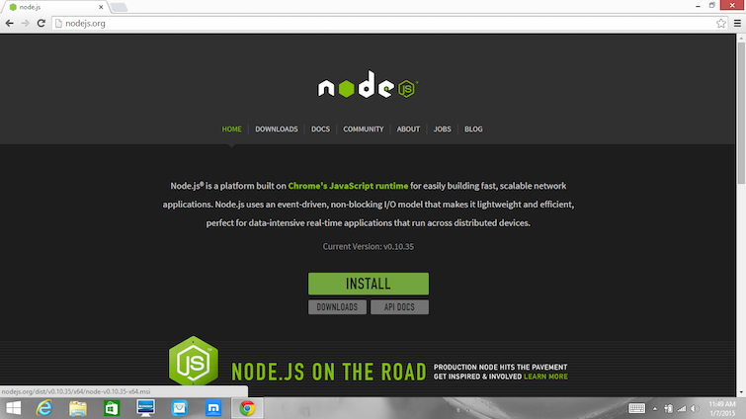

**2.** Run the installer (the .msi file you downloaded in the previous step.)

**3.** Follow the prompts in the installer (Accept the license agreement, click the NEXT button a bunch of times and accept the default installation settings).

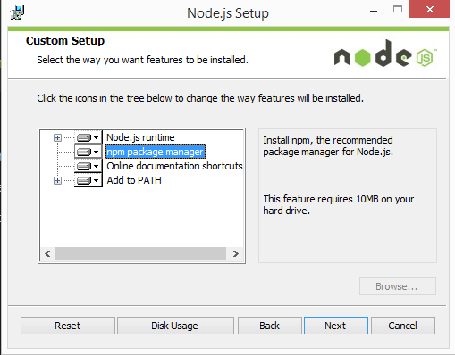

**4. Restart your computer.** You won’t be able to run Node.js until you restart your computer.

**After Installation Check the Version though Windows Command Prompt:**

**Commands:**

**NODE Version: C:/node –v NPM Version: C:/npm –v**

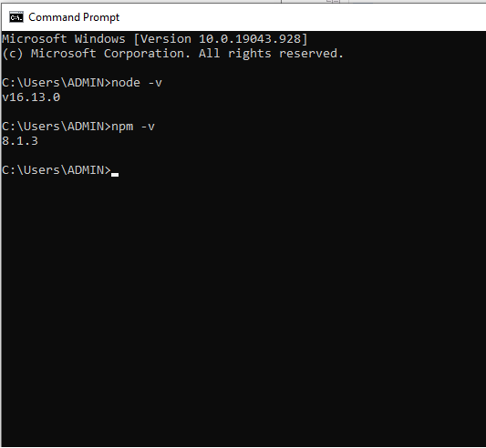

**Angular Installation:**

**Note:** Before the Angular we need install Visual studio code free editor and Node Js & npm package.

1. Open the Windows command prompt – cmd, enter the following command

**npm install -g @angular/cli**

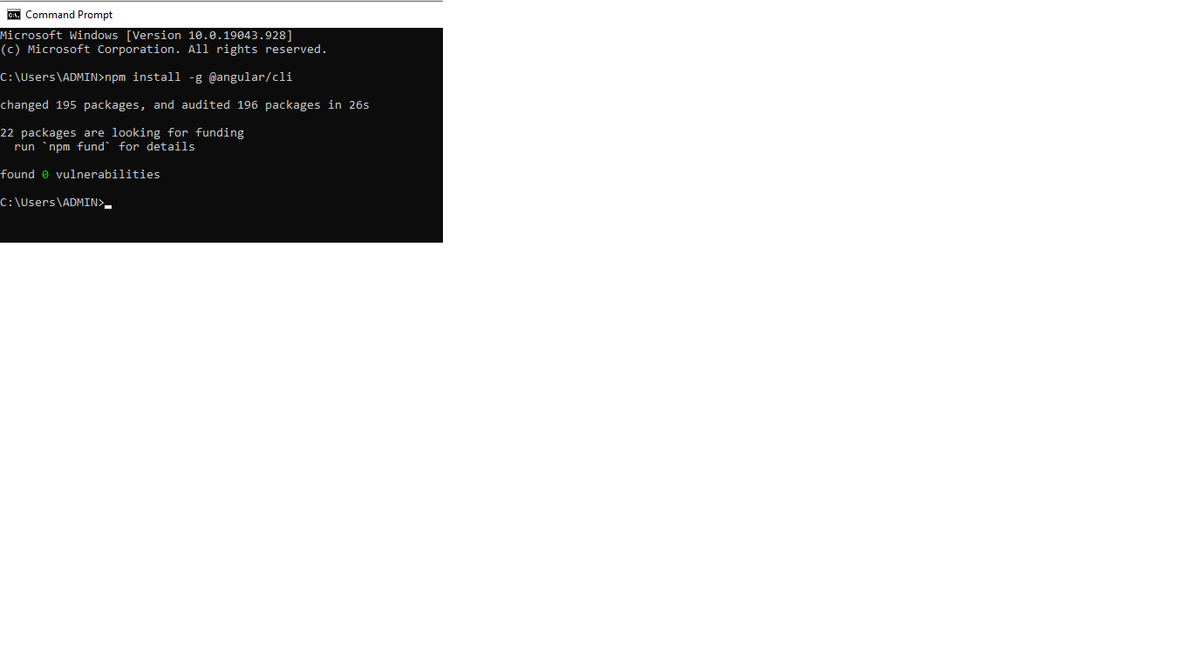

1. Once all packages have been added, verify the installed version

**ng - - version or ng v**

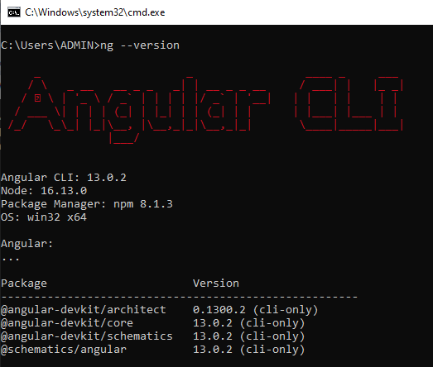

1. Create a new angular Application , using this command

**ng new hello-app**

**hello-app: application name**

